| **Job Sheet** |
| --- |

| **Module** | **:** | IoT Fundamentals | **Module Code** | **:** | EC33105FP | |
| --- | --- | --- | --- | --- | --- | --- |
|  |  |  |  |  |  | |
| **Job No** | **:** | 8 | **Duration** | **:** | F/T: | 2 hours |
|  |  |  |  |  | P/T: |  |

| **Job Title** | **:** | Setup IoT Platform |
| --- | --- | --- |
|  |  |  |
| **Objectives** | **:** | 1. Register for IoT Platform 2. Create Channel 3. Setup MQTT |

**Tools, Equipment and Materials**

| PC |
| --- |
|  |
|  |
|  |

**Number of Tasks to Complete**: 3

**Part A: Register for IoT Platform**

In this module, the IoT Platform that we are using is **ThingSpeak**.

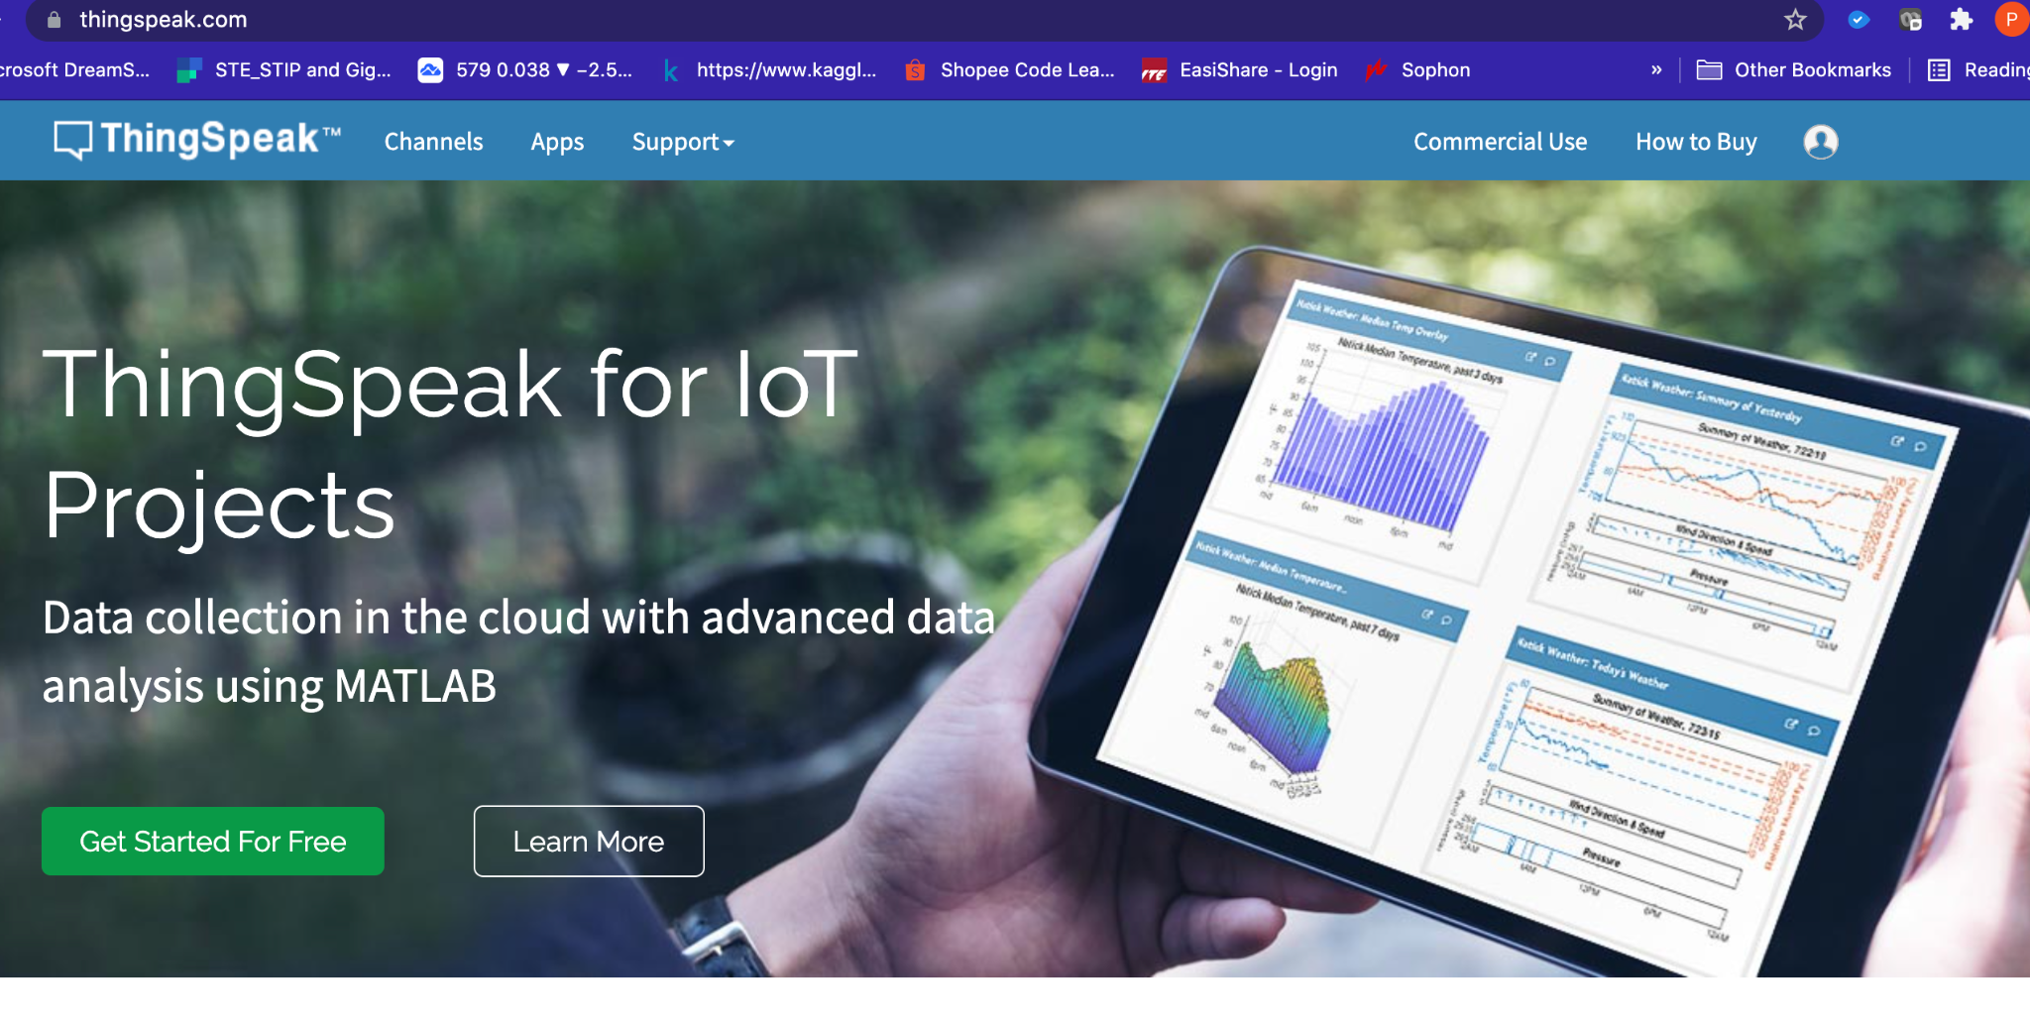

ThingSpeak is an IoT analytics platform service that allows you to aggregate, visualize, and analyze live data streams in the cloud. You can send data to ThingSpeak from your devices, create instant visualization of live data, and send alerts.

It uses the HTTP and MQTT protocol over the Internet to move data from sensor to cloud.

We will be using the **FREE account** to test sending data to the cloud, and later visualizing and acting on it.

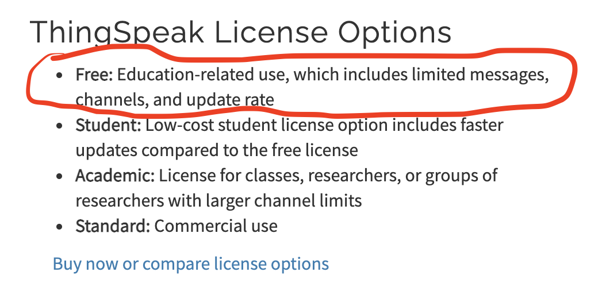

**Task 1 – Register for Thingspeak FREE account**

Perform the following steps

1. Go to <https://thingspeak.com/>
2. Click on the 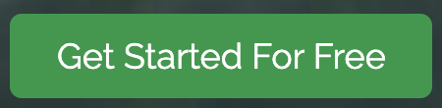 button.
3. If you do not have a MathWorks account, click on **Create One**

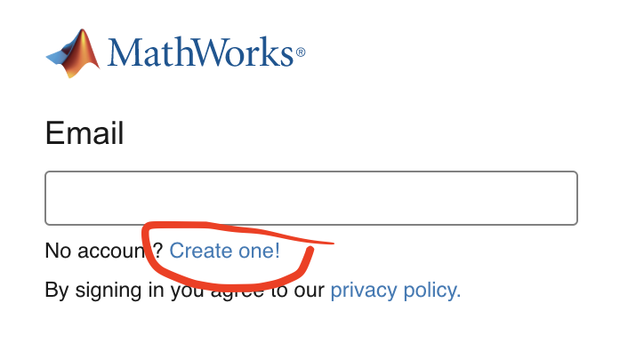

1. Fill in the following to register for an account and click **Continue**.

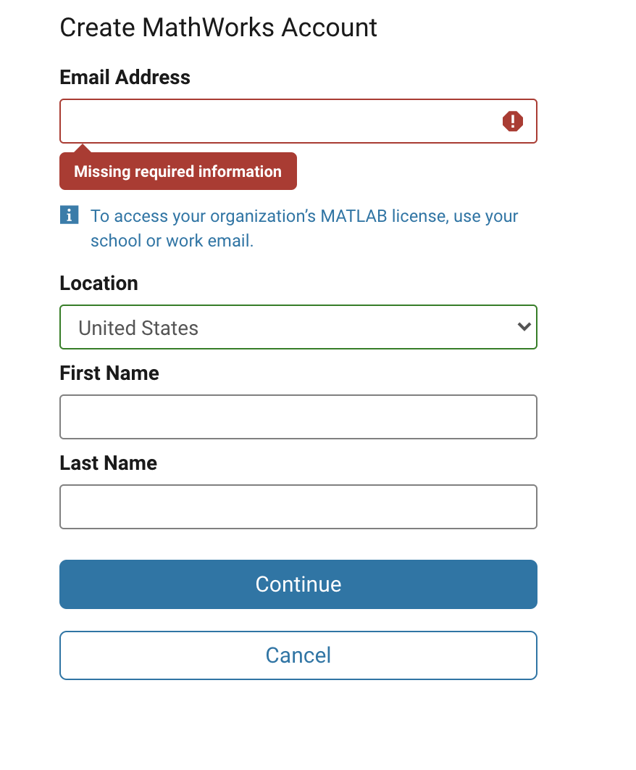

1. Logon to your email, and click **Verify Email** on the verification email.

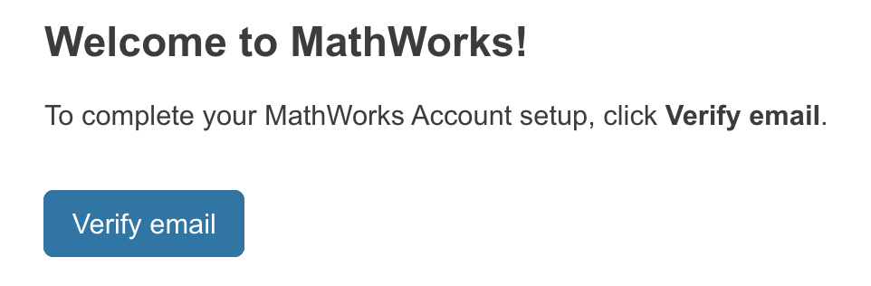

1. Once verified, fill in your name and password details.
2. Go back to
3. Login using your credentials.
4. Your sign up should be successful.

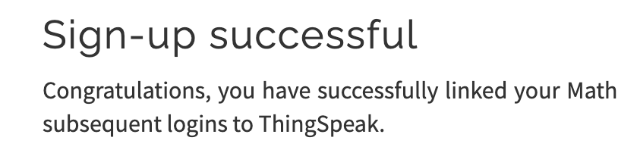

1. Click on **OK.** Once done you should see the option to create **Channels.**

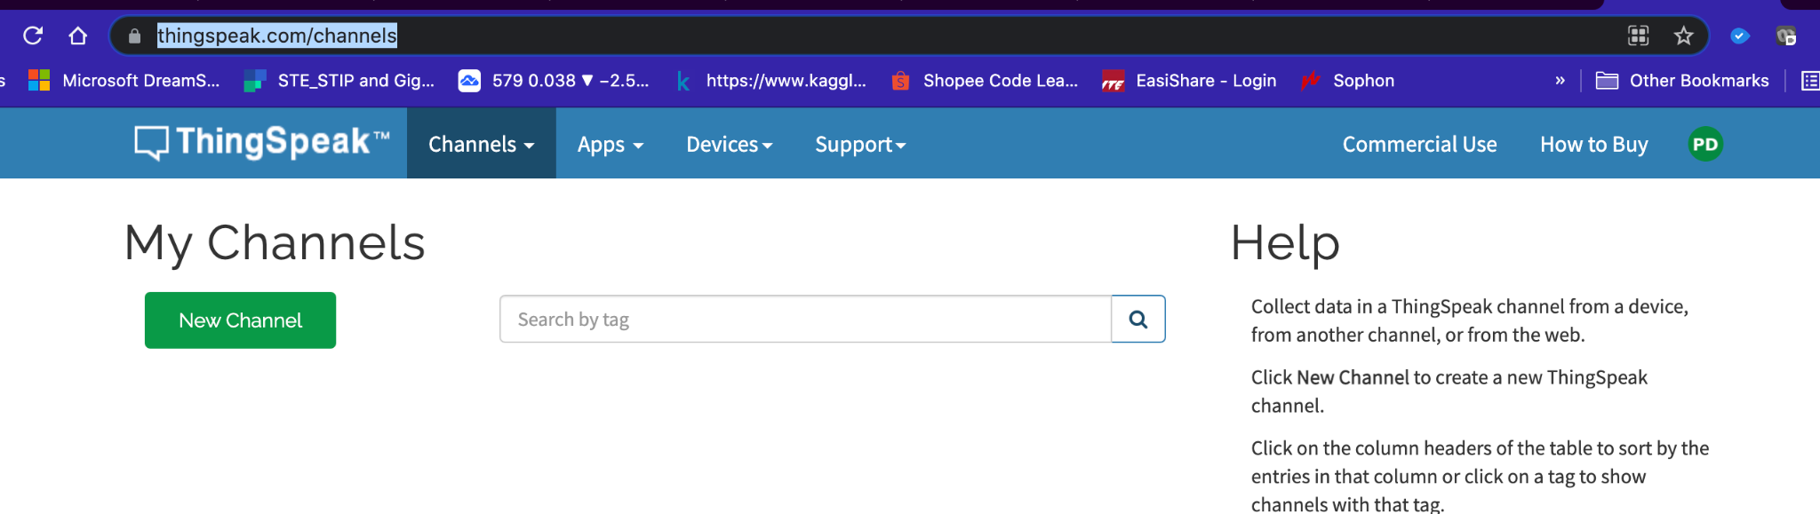

**Part B: Create Channels**

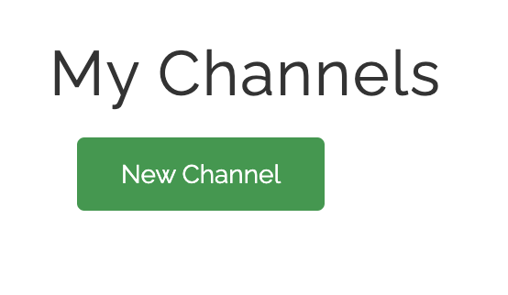

Channels store all the data that a ThingSpeak application collects. Each channel includes eight fields that can hold any type of data, plus three fields for location data and one for status data. Once you collect data in a channel, you can use ThingSpeak apps to analyze and visualize it.

**Task 2 – Create Channel**

Perform the following steps :

1. Click on 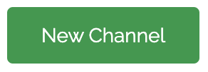
2. Give the channel a descriptive name. E.g. Rpi_[Your Name]

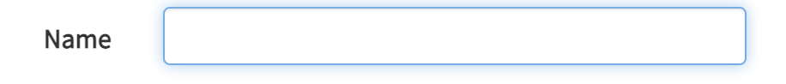

1. Create two fields as shown:

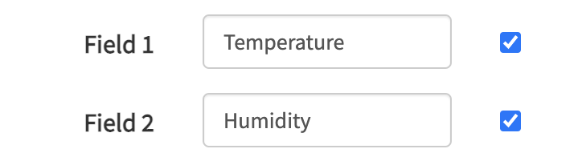

1. Click on 
2. You will see two charts created. In the next jobsheet, we will send in Temperature and humidity data collected by DHT11 connected to the RPi, to this dashboard.

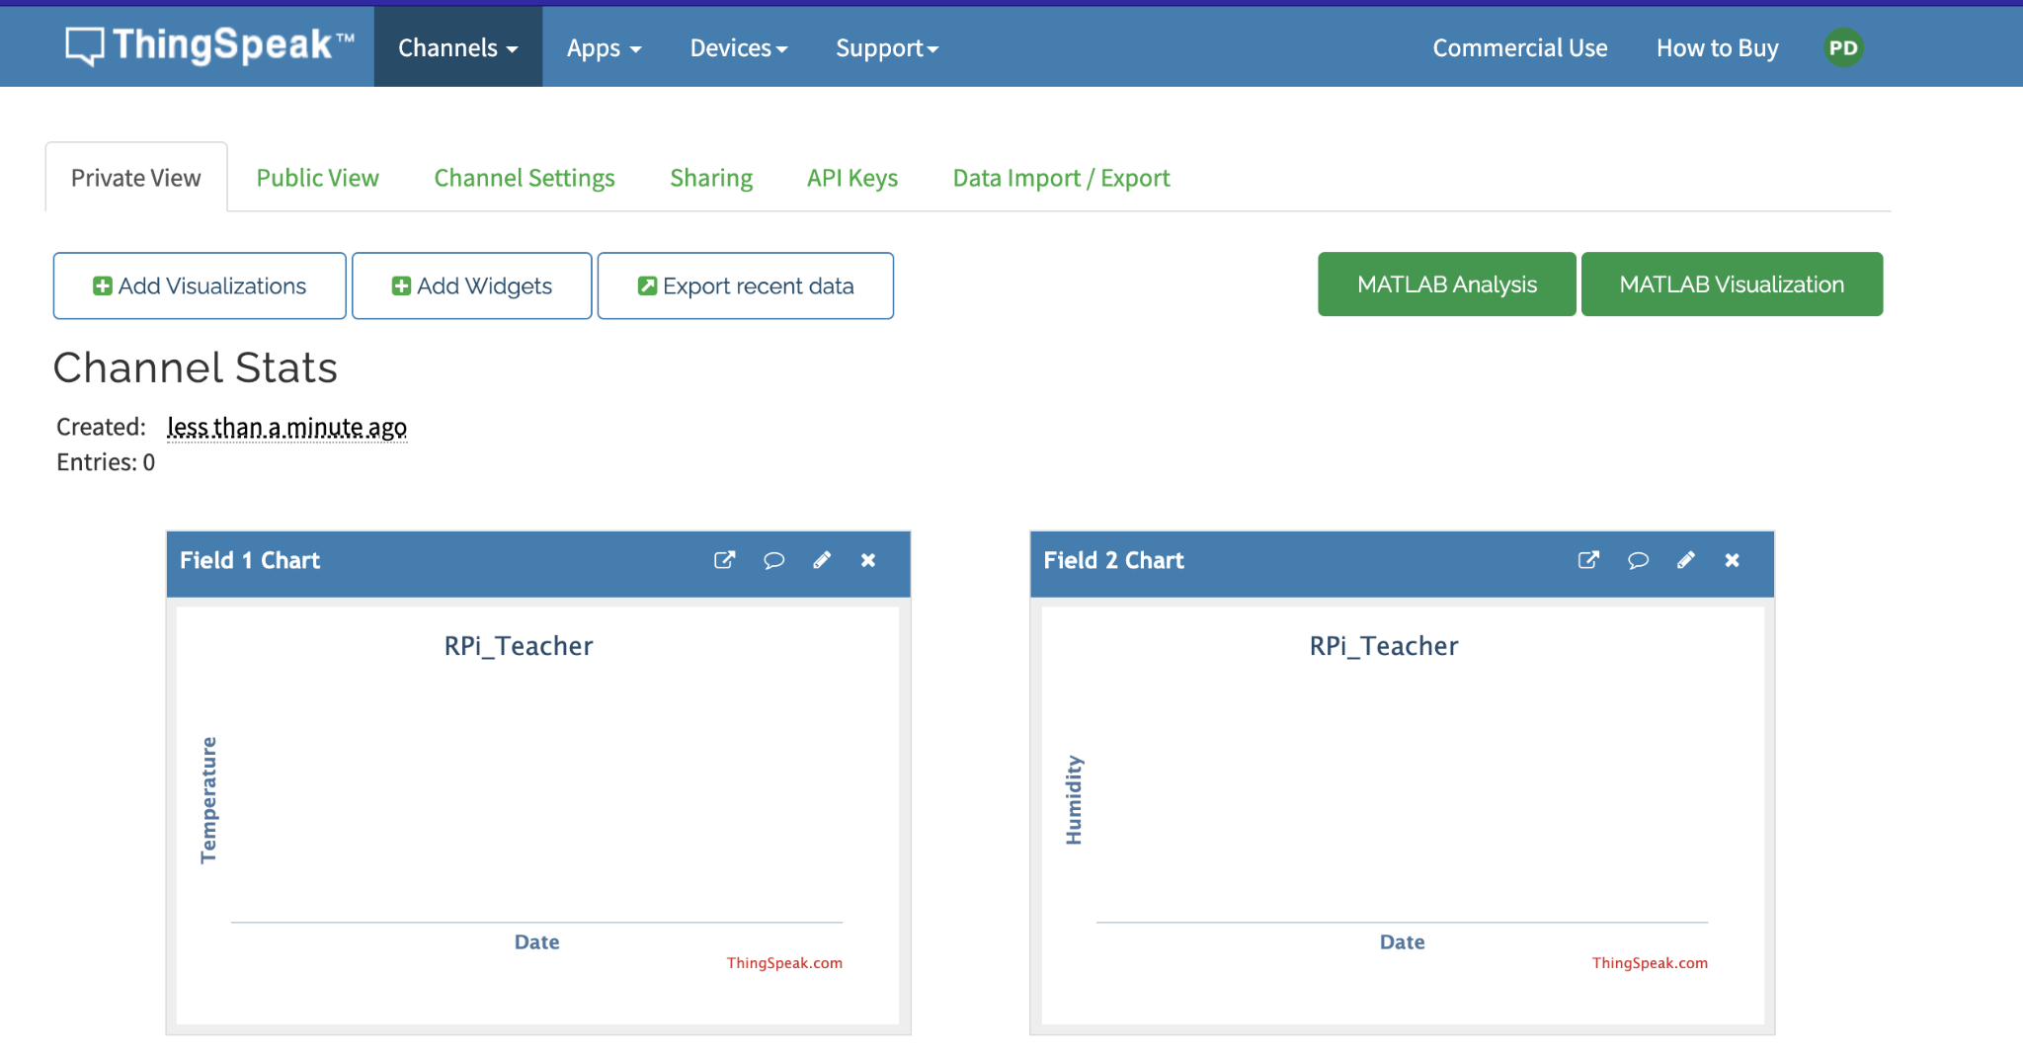

**Task 3 – Setup MQTT**

1. Setup MQTT by clicking on **Devices** and **MQTT.**

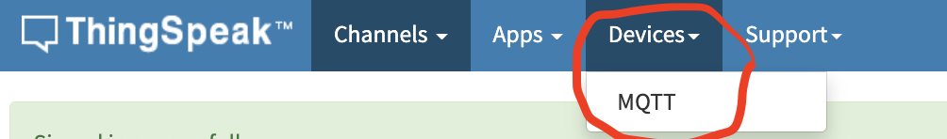

1. Click on **Add a new device**

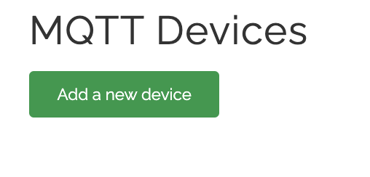

1. Give the channel a descriptive name. E.g. Rpi_Device_[Your Name].

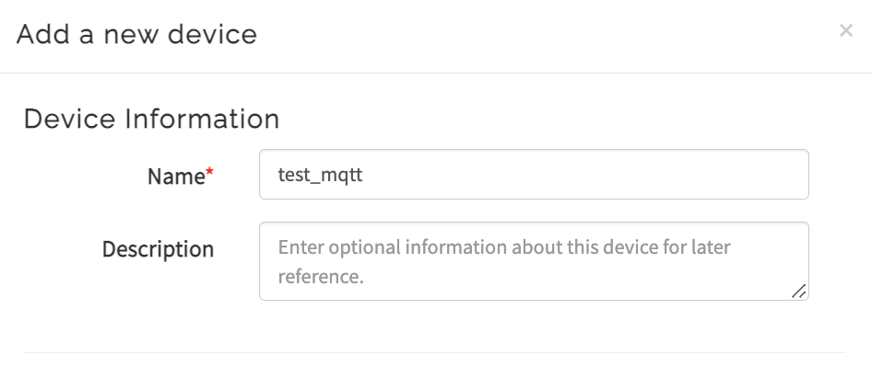

1. Select the channel created earlier in the dropdown list. Click on **Add Channel.**

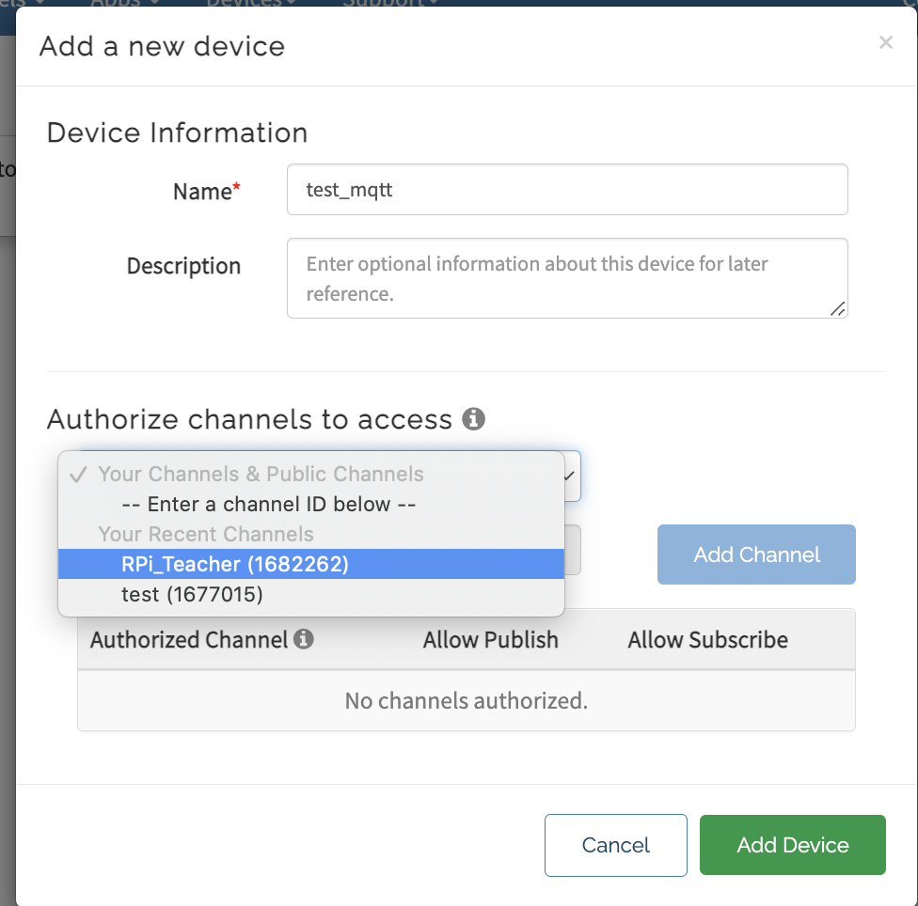

1. Allow both publish and subscribe as shown by checking the respective checkboxes.

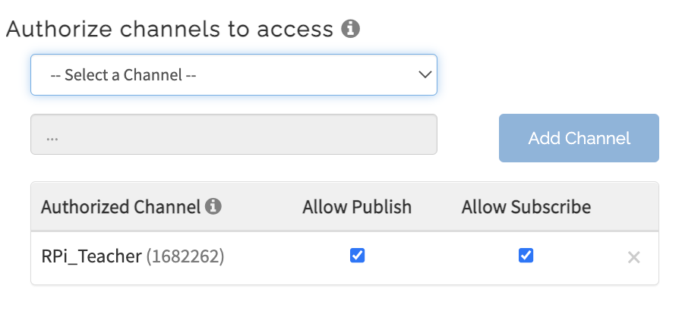

1. Download your credentials as a **Plain Text**.Keep it somewhere safe.

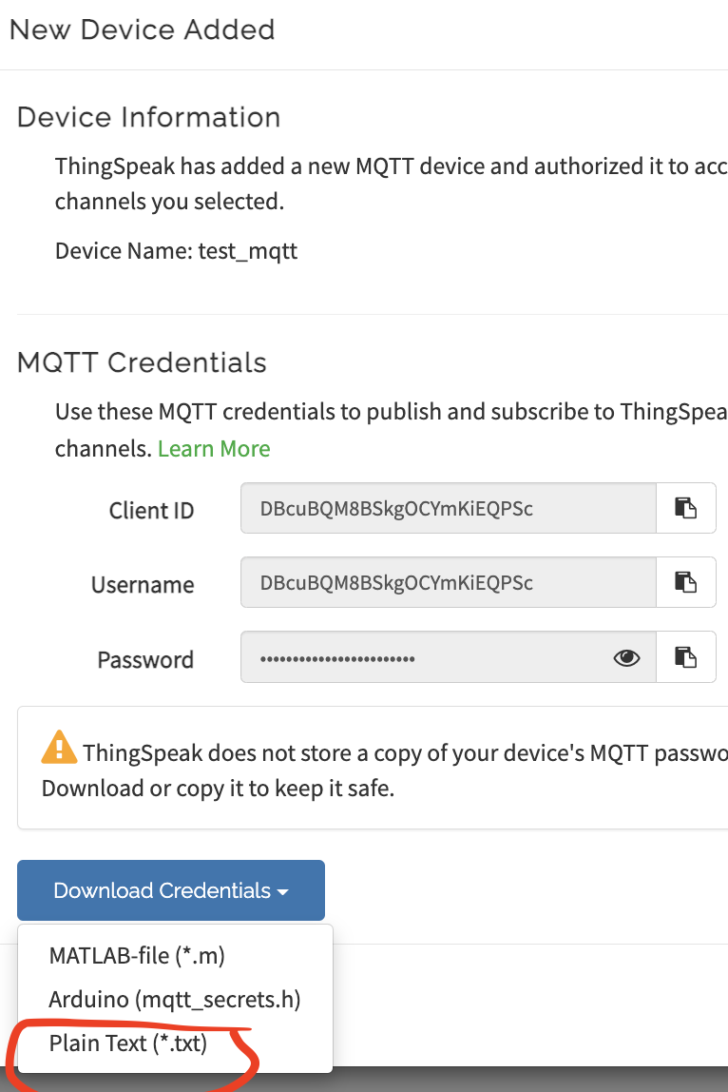

1. Click **Add Device.**

**Questions**

1. How many fields can one channel of ThingSpeak store (including location and status) ?



1. What protocols are supported in ThingSpeak ?

